[Topics]: [Required Software/Tools], [Steps], [Reference-Documentation], [Webhook Event Example], [Example]

[Required Software/Tools]:

1.ngRok -: <https://ngrok.com/download>

2.Stripe Cli -: <https://stripe.com/docs/stripe-cli>

[Basic Steps]

1. Download this tool from the given link
2. In dotnet core we need to install some NuGet packages for using Stripe and Webhook
   1. Stripe.Net
   2. NewtonJson
   3. MicrosoftMVC
3. For Stripe we create an account in Stripe
4. For Webhook creation you need to go to developer option in home page of Stripe and then select Webhooks and click on Add Endpoint.

Stripe>>>Developers (Test Mode)>>>Webhooks>>>Click on Add Endpoint.

1. For creating an endpoint, we need to make a One Post request in Dotnet Core.
2. now install the ngRok and run command

Ex. (ngRok http https://localhost:44308/)

1. After that ngRok provide use the global accessible link and that endpoint needs to be exposed to the Stripe and write the endpoint of your API.

Ex.(https://f435-2405-201-2036-c807-51aa-1e5a-a12d-2dff.in.ngrok.io/api/StrikeWebHook/Invoice-created)

1. After that we need to select or add an event as per requirement and based on requirements the Stripe is Provide a code for that event.  
   Ex.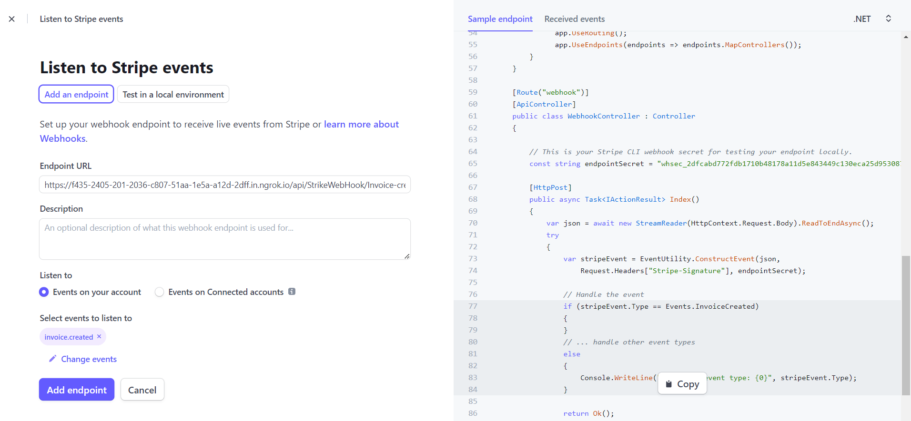
2. We need add that code in our code in Dotnet.

**[Crucial and Most Important Steps]**

Getting a Stripe call to your Code you need to add Endpoint Secret Key in your Code.

1. For getting endpoint secret key follow the Path

Stripe>>>Developers (Test Mode)>>>Webhooks>>>Click on Webhook URL>>>Signing Secret

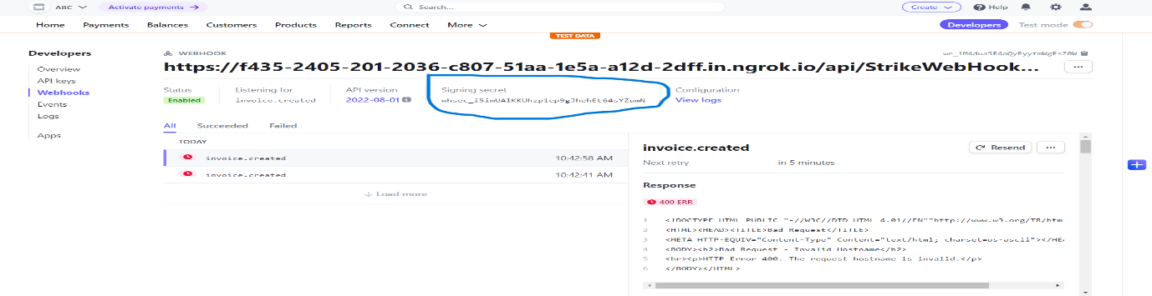

1. Add that key into your Code as given in Example

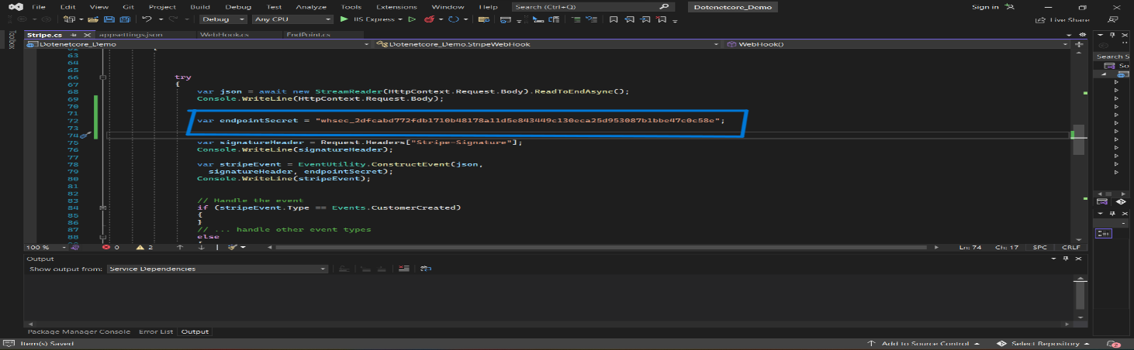

1. For Run the code Open Stripe Cli and Run command

Stripe listen –forward-to (localhost link with Endpoint’s)

Ex.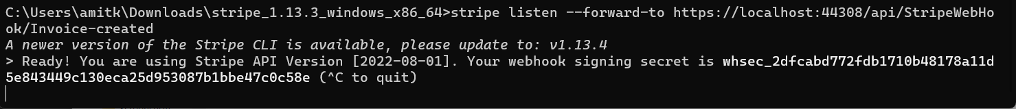

1. Now open another window of the same Stripe Cli and trigger the event whatever you are selected in the event when you are creating a Webhook.

Ex. stripe trigger Invoice.created

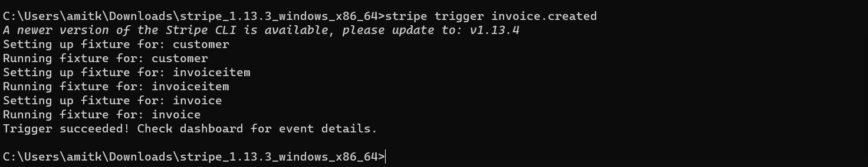

Now you are getting the Status 200 as an output and the event is created and run successfully.

Ex.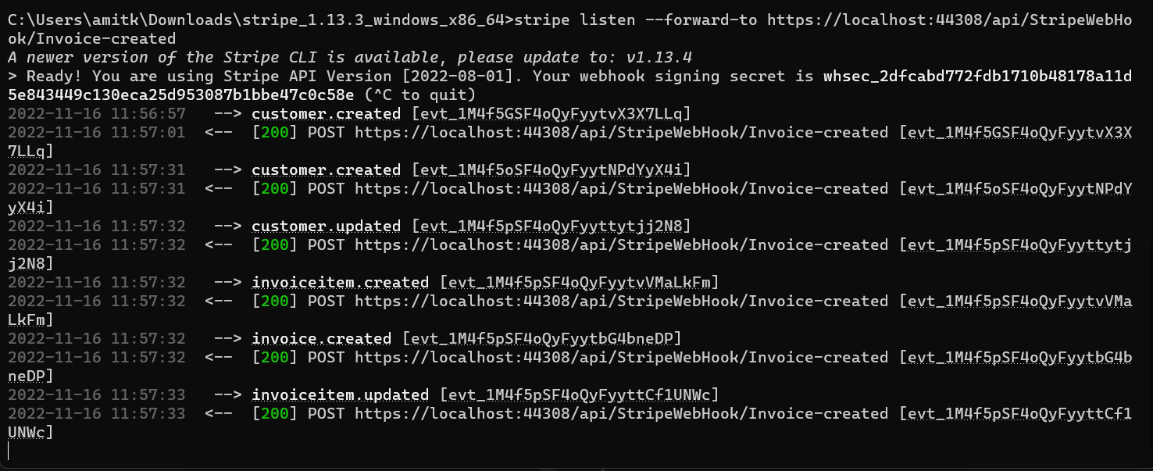

[Reference Links]

<https://www.youtube.com/watch?v=pQQH1bLVqjM>

<https://stripe.com/docs/stripe-cli/overview>

<https://dashboard.stripe.com/test/developers>

**Note-: First tigger the event and then and then you are getting the 200 status, because HttpContext.Request.Body are getting the data from created event if is already a created event then you can run it directly.**